# Exercises: Introduction to Hibernate

This document defines the exercise assignment part of the [“Databases Frameworks” course @ SoftUni](https://softuni.bg/trainings/1635/databases-frameworks-hibernate-and-spring-data-june-2017).

## Setup

Use the **provided skeleton** to create **soft_uni** database.

1. Change the **port**, **username** and **password** accordingly to your settings.

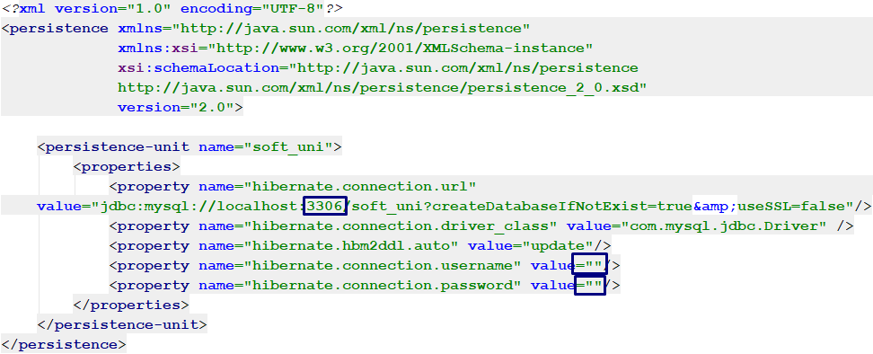

1. **Create** EntiryManagerFactory and **run** your program.



1. Fill the database into HeidiSQL by **executing** the provided **.sql** script.

## Remove Objects

Use **soft_uni** database. Persist **all towns** from the database. Detach those whose name length is **more than 5 symbols**. Then transform the **name** of all attached towns **to lowercase** and **save them to the database**.

## Contains Employee

Use **soft_uni** database. Write a program that check if given employee name as an input **is contained in the database.**

### Example

|  |  |
| --- | --- |
| **Input** | **Output** |
| Svetlin Nakov | Yes |
| John Doe | No |

## Employees with Salary Over 50 000

Write a program to get the first name of all employees who have salary over **50 000**.

### Example:

|  |
| --- |
| **Output** |
| Terri  Jean  Ken  … |

## Employees from Department

Extract all employees from the **Research and Development** department. Order them by **salary** (in ascending order), then by **id** (in asc order). Print only their **first name**, **last name**, **department name** and **salary**.

### Example:

|  |
| --- |
| **Output** |
| Diane Margheim from Research and Development - $40900.00  Gigi Matthew from Research and Development - $40900.00  Michael Raheem from Research and Development - $42500.00  Svetlin Nakov from Research and Development - $48000.00  Martin Kulov from Research and Development - $48000.00  George Denchev from Research and Development - $48000.00  Dylan Miller from Research and Development - $50500.00 |

## Adding a New Address and Updating Employee

Create a new address with **text** "**Vitoshka 15**". Set that address to an employee with last name from user input.

## Addresses with Employee Count

Find all addresses, **ordered** by the **number of employees** who live there (**descending**), then by **town id** (**ascending**). Take only the **first 10 addresses** and print their **address text**, **town name** and **employee count**.

### Example

|  |
| --- |
| **Output** |
| 163 Nishava Str, ent A, apt. 1, Sofia - 3 employees  7726 Driftwood Drive, Monroe - 2 employees  2427 Notre Dame Ave., Redmond - 1 employees  3066 Wallace Dr., Redmond - 1 employees  101 Candy Rd., Redmond - 1 employees  2482 Buckingham Dr., Redmond - 1 employees  3768 Door Way, Redmond - 1 employees  1275 West Street, Redmond - 1 employees  3397 Rancho View Drive, Redmond - 1 employees  2383 Pepper Drive, Redmond - 1 employees |

## Get Employee with Project

Get an **employee by id**. Print only his/her **first name**, **last name**, **job title** and **projects** (only their names). The projects should be **ordered** **by** **name** (ascending). The output should be printed in the format given in example.

### Example

|  |  |
| --- | --- |
| **Input** | **Output** |
| 147 | Linda Randall - Production Technician  HL Touring Handlebars  ML Road Rear Wheel  Patch kit  Touring-1000 |
| 83 | John Evans - Production Technician  Half-Finger Gloves  LL Mountain Handlebars  Racing Socks  Women's Tights |

## Find Latest 10 Projects

Write a program that prints **last 10 started projects**. Print **their name, description, start and end date** and **sort** **them by name** lexicographically. See example for output format.

### Example

|  |
| --- |
| **Output** |
| Project name: All-Purpose Bike Stand  Project Description: Research, design and development of …  Project Start Date:2005-09-01 00:00:00.0  Project End Date: null  Project name: Bike Wash  Project Description: Research, design and development of …  Project Start Date:2005-08-01 00:00:00.0  Project End Date: null  Project name: HL Touring Frame  Project Description: Research, design and development of …  Project Start Date:2005-05-16 16:34:00.0  Project End Date: null  … |

## Increase Salaries

Write a program that increases salaries of all employees that are in the **Engineering**, **Tool Design**, **Marketing** or **Information Services** department by **12%**. Then **print first name, last name and salary** for those employees whose salary was increased.

### Example

|  |
| --- |
| **Output** |
| Kevin Brown ($15120.00)  Rob Walters ($33376.00)  Thierry D'Hers ($28000.00)  Ashvini Sharma ($36400.00)  … |

## Remove Towns

Write a program that **deletes town** which name is given as an input. Also **delete all addresses** that are in those towns. Print on the console the number addresses that were deleted as given in the example:

### Example

|  |  |
| --- | --- |
| **Input** | **Output** |
| Sofia | 1 address in Sofia deleted |
| Seattle | 44 addresses in Seattle deleted |

## Find Employees by First Name

Write a program that finds all employees whose first name starts with pattern given as an input from the console. Print their first, last name, their job title and salary in the format given in the examples below.

### Example

|  |  |
| --- | --- |
| **Input** | **Output** |
| SA | Sariya Harnpadoungsataya - Marketing Specialist - ($14400.00)  Sandra Reategui Alayo - Production Technician - ($9500.00)  Sairaj Uddin - Scheduling Assistant - ($16000.00)  Samantha Smith - Production Technician - ($14000.00)  Sameer Tejani - Production Technician - ($11000.00)  Sandeep Kaliyath - Production Technician - ($15000.00) |

## Employees Maximum Salaries

Write a program to find the **max salary** for each **department**. Filter those which have max salaries not in the range 30000 and 70000.

### Example

|  |
| --- |
| **Output** |
| Tool Design - 29800.00  Sales - 72100.00  … |